Academy Learning Portal: the new design is finally here!

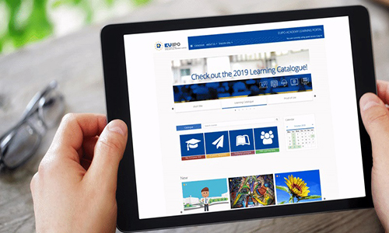

Have you noticed that the [**Academy Learning Portal**](https://euipo.europa.eu/knowledge/) has been updated?

Indeed, under the scope of the strategic project e-learning Portal – Next Generation, the Academy Learning Portal (ALP) has a completely new look and feel with some brand new features.

Now, your learning experience is more enjoyable than ever, thanks to the **enhanced user experience**.

* **Look and feel**: with fresh, clean-cut and content-focused design, the left-hand menu helps you navigate the Learning Portal more easily and interact better with courses that interest you by focusing on their content. You can also access the Personal Dashboard, Search and Course Catalogue via this menu.
* **Carousels**: this new feature **on the home page** that includes relevant courses will make browsing the ‘New’ and ‘Most Popular’ ones easier and more interactive than ever before.
* **Advanced search**: searching for courses in the ALP catalogue that most interest you is now easier, more flexible and faster. You can filter the results in **just one click**.
* You can pick your favourite courses and share them on **social media**!

Finally, the Academy Learning Portal now includes a new learning area under development dedicated to small and medium enterprises (SMEs), where they can gain experience and learn about their valuable assets.

**Ready to learn? Stay tuned!**